SAFEGRID-AI: AN EXPLAINABLE MULTI-AGENT SYSTEM FOR DYNAMIC POWER ROUTING
Conclusion, Future Scope and References
Department of Computer Science and Engineering, TKR College of Engineering and Technology (Autonomous)
Batch A13 (CSE-A) · Academic year [ACADEMIC YEAR]
Table 1: Project team
S.No. | Student name | Roll number
1 | DISHA KAUSHAL | 23K91A0563
2 | BOLLAM RAKESH | 23K91A0542
3 | CHINNOLLA RAVINDHAR | 23K91A0554
4 | AFFAN MOHAMMED RAMY | 23K91A0505

Project guide: CHANDRASHEKAR
Chapter and section numbers quoted in the text (for example Section 6.6 or Chapter 8) refer to the full project report, 17.Final Document. Figures and tables in this document are numbered from 1.

Summary
This project set out to show that autonomous agents can be allowed to propose control actions for a power network without being allowed to execute them. The system that resulted, SafeGrid-AI, has three agents on a simulated three-node low-voltage feeder, a coordinator that detects conflicts and orders proposals, and a Symbolic Safety Shield that validates every proposal with an AC power flow and returns one of three verdicts: approved, projected (scaled to the largest safe size) or rejected. Only validated set-points are committed to the simulated grid. Each non-approved decision is written to a SHA-256 hash-chained log, and each decision carries a structured explanation. The system is served by a FastAPI interface with a WebSocket stream and a React console, and is evaluated with a three-strategy experiment on seven seeded scenarios.

What the Measurements Show
Across 21 shielded runs (1,512 agent proposals) the shield approved 1,162 (76.9 %), projected 237 (15.7 %) and rejected 113 (7.5 %), and no executed action created or worsened a limit violation (0 of 504 steps), whereas the same agents without the shield did so in 99 steps (144 violations).
The shield intervened on 23.1% of proposals, mostly by scaling them down rather than refusing them. The mean number of steps with any limit violation after execution fell from 6.38 (agents without the shield) and 6.05 (rule baseline) to 2.48 with SafeGrid-AI, although 6.33 steps per run are stressed by the scenario even when every agent is idle. The price is compute and some renewable energy: 347.8 ms per step against about 106 ms, and renewable utilisation of 0.860 against 0.884 without the shield.
Single-run traces make the same point visually: in the congestion scenario the unshielded agents push a line to 137.7 % of its rating, while with the shield it never exceeds 100.0 %; in the voltage scenario the highest voltage is 1.117 pu without the shield and 1.056 pu with it, which is still above 1.05 pu because the scenario already breaks the limit with every agent idle.
Table 2: Headline measurements (mean per 24-step run, 21 runs per strategy)
Metric | Rule baseline | Agents, no shield | SafeGrid-AI
Steps with violations caused by actions | 2.19 | 4.71 | 0.00
Steps with any violation after execution | 6.05 | 6.38 | 2.48
Energy cost (INR, illustrative) | 216.4 | 380.8 | 225.0
Renewable utilisation | 1.000 | 0.884 | 0.860
Mean step time (ms) | 107.9 | 106.2 | 347.8

Beyond the averages, the system behaved as designed in the situations built to test it: a 1,000 kW export was rejected, a 900 kW import was rejected, a malformed output became a labelled fallback decision, a congested feeder never exceeded its rating, and the dashboard displayed each of these decisions with its reasons.

Contributions
The work contributes a verdict that can reduce a request instead of only vetoing it, an attribution rule that separates violations caused by an action from those already present, a shield whose independence from the language-model code is enforced by a test, structured explanations without stored chain-of-thought, a tamper-evident audit trail and a three-arm evaluation that includes the counterfactual of what the raw proposals would have done. Measured against the six objectives of the batch, four were achieved, one was achieved with a mock model and one, violation resolution, was achieved in part.

Lessons Learned
• Measure the counterfactual. Reporting only what happened with the shield on would have made the result a statement about the scenarios. Computing, in the same step, what the raw proposals would have done turned it into a statement about the shield.
• Separate harm from stress. A metric that simply counts violations per step would charge the shield with stress that no action caused. The attribution rule avoids that, and it also exposes the cases (peak demand) where the shield leaves more stress than a simple controller.
• Say what a number is. A decision latency of 0.17 ms, a classification metric that does not exist, or a 'guarantee' stronger than the tests all look like results; writing down what each one is not kept the report honest.
• Keep the checker small and dull. The whole safety package is 621 lines of ordinary deterministic code (of 3,117 backend lines) with 22 dedicated unit tests, a deliberate contrast with the component it supervises.

Limits of the Conclusion
These conclusions are conditional. No real language model was evaluated; every agent decision came from a deterministic mock. The feeder is a three-node simulation with synthetic profiles and an illustrative tariff, and the experiment has three seeds. The safety guarantee is that executed actions do not create or worsen a violation of the configured limits in the simulated model; it is not a proof and it does not promise a violation-free grid. The comparison with the base paper [1] is qualitative. Two grid unit tests fail on numeric tolerances, one WebSocket test hangs, and no user study was carried out.

Closing Remark
The practical lesson is architectural. A language model, or any other flexible proposer, is most useful when the system around it assumes that it will sometimes be wrong, and makes being wrong cheap: a narrow action schema, an independent deterministic validator, a clear record of what was changed and why, and an interface in which a person can check any decision. SafeGrid-AI is a small, honest demonstration of that pattern, together with a clear list of what remains to be shown.
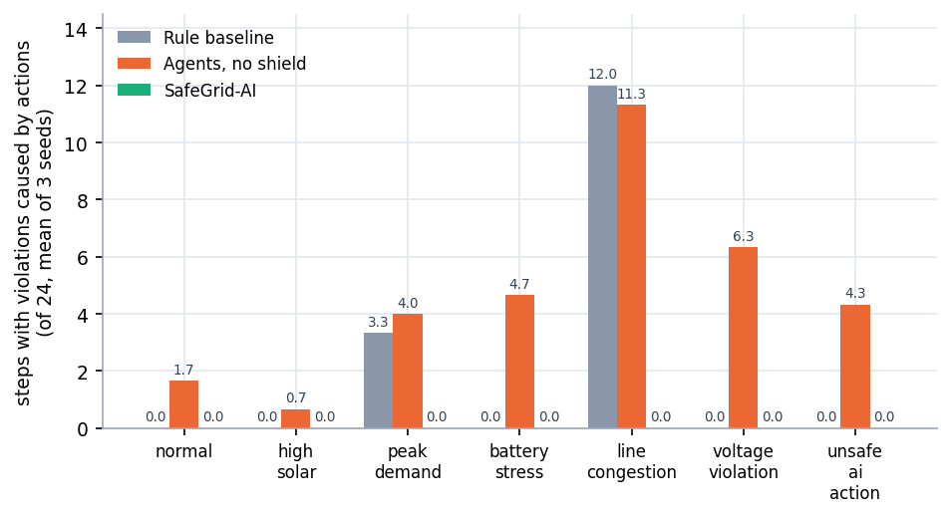
Figure 1: Steps with violations caused by actions, per scenario and strategy (mean of three seeds): the evidence behind the conclusion

Evaluate with a Real Language Model
Every agent result in this report comes from a deterministic mock provider, so the most valuable next step is to run the existing API provider against a hosted model and repeat the 63-run experiment. The report should then include decision latency (the mock's 0.1-0.2 ms is meaningless), token cost, the rate of outputs that fail schema validation, the fallback rate and a comparison of reasoning quality between models, as in the model-by-model success rates reported for Grid-Agent [2].
The experiment design is ready for this: the provider interface, the schema validation of model output, the time-out and the labelled fallback already exist, and the experiment runner accepts a provider name. What is missing is an API key, a budget and a decision about which models to compare. A reasonable protocol is the same seven scenarios and three arms with at least ten seeds, with the model's temperature fixed, so that variation between seeds reflects the scenario and not sampling noise; wall-clock time per step would then be dominated by model latency, and the shield's 0.35 s per step would no longer be the bottleneck.

Measure and Improve Resolution
Objective 6 asked for a violation resolution rate, which was not measured. Add a metric for the share of pre-existing violation steps that are cleared, and give the planner an objective that rewards clearing them. The peak_demand scenario shows why: the rule baseline leaves 7.33 steps with a violation, the shielded agents 8.67, because a veto-only layer prevents harm but does not look for relief.

Stronger Guarantees
• State the shield's guarantee as a theorem about an explicit model and check it with a verifier; the present claim is model-relative and rests on tests.
• Test the monotonicity assumption of the bisection (that a smaller action is never less safe) on more network types and on three-phase models.
• Add adversarial evaluation: prompt-injection attacks on a hosted model, measuring what reaches the grid.
A formal statement needs three ingredients: the model (the quasi-static AC power flow and the battery model), the property (no executed action creates or worsens a violation of the configured limits) and the assumptions (monotone safety under scaling, the tolerance of the attribution rule). The first two can be written down directly; the third is where a verifier or an exhaustive test over a fine grid of actions would provide real evidence, because it is the assumption the bisection relies on.

Realism and Scale
• Larger benchmark networks of the kind used in related work [2], with measured scaling of trial power flows per step.
• Three-phase unbalanced feeders, forecasts for solar and load, real tariffs and measured profiles in place of synthetic ones.
• Dynamics and protection through a real-time simulator or hardware in the loop before any field use.
Measured profiles would also change the picture. Solar output on a real day, a metered household load shape and a real tariff would move the numbers for cost and renewable utilisation, and might change which scenarios are hard; the present synthetic profiles were chosen to be transparent and reproducible, not to be representative.

Operator-Facing Features
• Human-in-the-loop approval of projected and rejected actions, recorded in the same hash chain, following the human-oversight requirements discussed for agent-assisted grid studies [3].
• A Model Context Protocol tool interface for the simulator and the shield [3].
• Real authentication, roles and server-side key storage, replacing the browser-side demo gate.
• A user study of the decision lane, dry run and audit view with students and operators.
The order in which these should be done is: approval workflow first, because it changes the role of the shield from automatic to supervised; the tool interface second, because it lets other agents use the system; the user study third, because it needs the first two to be meaningful; authentication last, because it matters only once a deployment target exists.

Engineering Clean-up
• Repair the two failing grid tests (compute the expected value in the test instead of fixing 10.0 kW and -3.123 kW) and the hanging WebSocket test (use an asynchronous client).
• Reduce the roughly threefold step-time cost of the shield with sensitivity screening or cached factorisations.
• Containerise, add server-side persistence and run the experiment as a scheduled job with archived results.

Suggested Order of Work
Table 3: Roadmap
Step | Work | Result expected
1 | Repair the two grid tests and the WebSocket test | A green regression suite
2 | Run the 63-run experiment with a hosted model and at least ten seeds | Real latency, cost, fallback rate; the shield's benefit against a real proposer
3 | Add a resolution metric and a revise-after-veto loop | Evidence on whether the planner can clear pre-existing violations
4 | Move to benchmark feeders and a three-phase model | Scaling behaviour of trial power flows; relevance beyond three nodes
5 | Human approval workflow and a user study | Usability and trust data
6 | Formal statement and verification of the shield's guarantee | A stronger, model-relative guarantee with stated assumptions

The first two steps are cheap and answer the questions a reader will ask first; the others each open a new line of work and can proceed in parallel once a real model is available.

REFERENCES
[1] S. E. Eyimaya and N. Altin, "Design of multi-agent-based energy management system for DC microgrids," IEEE Access, vol. 14, pp. 39120-39133, 2026, doi: 10.1109/ACCESS.2026.3672618.
[2] Y. Zhang, A. M. Saber, A. Youssef, and D. Kundur, "Grid-Agent: An LLM-powered multi-agent system for power grid control," arXiv:2508.05702, Aug. 2025.
[3] J. Picault and C. Goubet, "Orchestrating power grid studies with multi-agent AI and MCP servers," arXiv:2607.14158, Jul. 2026.
[4] "Multi-agent deep reinforcement learning for energy-efficient smart grid management," in Proc. 1st Int. Conf. Intelligent Methods and Advanced Computer Scientific Innovations, 2025. (Authors not recorded in the batch survey.)
[5] "Energy system fault reconstruction control strategy based on multi-agent deep reinforcement learning," in Proc. 6th Int. Conf. Energy, Power and Grid (ICEPG), 2024. (Authors not recorded in the batch survey.)
[6] "Distributed optimal scheduling for electric vehicles considering the multi-agent demands of electric vehicles, charging stations and power grid," in Proc. 3rd Int. Conf. Power, Grid and Energy Storage, 2025. (Authors not recorded in the batch survey.)
[7] "Multi-agent systems in power system: A comprehensive review of energy management in power grid," in Smart Grid Security and Protection, Lecture Notes in Electrical Engineering, 2025. (Authors not recorded in the batch survey.)
[8] S. D. J. McArthur et al., "Multi-agent systems for power engineering applications - Part I: Concepts, approaches, and technical challenges," IEEE Trans. Power Syst., vol. 22, no. 4, pp. 1743-1752, Nov. 2007, doi: 10.1109/TPWRS.2007.908471.
[9] R. H. Lasseter, "MicroGrids," in Proc. IEEE Power Eng. Soc. Winter Meeting, vol. 1, 2002, pp. 305-308, doi: 10.1109/PESW.2002.985003.
[10] H. Farhangi, "The path of the smart grid," IEEE Power Energy Mag., vol. 8, no. 1, pp. 18-28, Jan./Feb. 2010, doi: 10.1109/MPE.2009.934876.
[11] L. Thurner et al., "pandapower - An open-source Python tool for convenient modeling, analysis, and optimization of electric power systems," IEEE Trans. Power Syst., vol. 33, no. 6, pp. 6510-6521, Nov. 2018, doi: 10.1109/TPWRS.2018.2829021.
[12] M. Alshiekh, R. Bloem, R. Ehlers, B. Konighofer, S. Niekum, and U. Topcu, "Safe reinforcement learning via shielding," in Proc. AAAI Conf. Artif. Intell., 2018, pp. 2669-2678.
[13] G. Dalal, K. Dvijotham, M. Vecerik, T. Hester, C. Paduraru, and Y. Tassa, "Safe exploration in continuous action spaces," arXiv:1801.08757, 2018.
[14] J. Garcia and F. Fernandez, "A comprehensive survey on safe reinforcement learning," J. Mach. Learn. Res., vol. 16, pp. 1437-1480, 2015.
[15] D. Amodei, C. Olah, J. Steinhardt, P. Christiano, J. Schulman, and D. Mane, "Concrete problems in AI safety," arXiv:1606.06565, 2016.
[16] S. Yao et al., "ReAct: Synergizing reasoning and acting in language models," in Proc. Int. Conf. Learn. Represent. (ICLR), 2023.
[17] M. Turpin, J. Michael, E. Perez, and S. R. Bowman, "Language models don't always say what they think: Unfaithful explanations in chain-of-thought prompting," in Proc. Adv. Neural Inf. Process. Syst. (NeurIPS), 2023.
[18] M. Wooldridge, An Introduction to MultiAgent Systems, 2nd ed. Chichester, U.K.: Wiley, 2009.
[19] Voltage Characteristics of Electricity Supplied by Public Electricity Networks, European Standard EN 50160:2010, CENELEC, 2010.
[20] Secure Hash Standard (SHS), Federal Information Processing Standards Publication FIPS 180-4, NIST, Aug. 2015.

